1. UNION ALL

THREE EMPLOYEE FILE IN EXCEL AND TRANSFERING IN ONE SQL DESTINATON FILE BY USING UNION ALL AND DATA CONVERSION

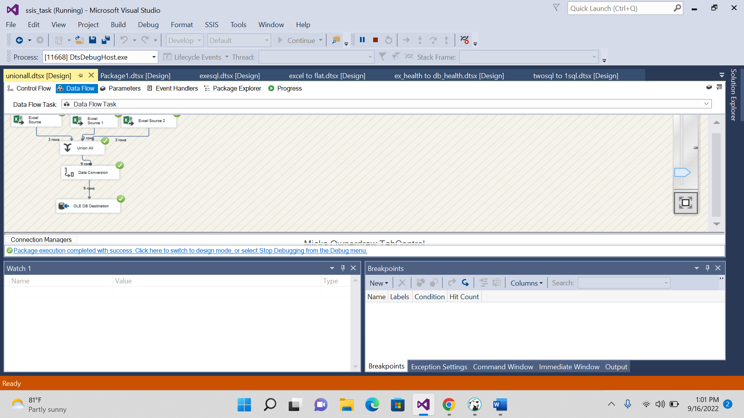

QUERIES

**create** **table** LV__employeeunion(

emp_name **varchar**(50),

emp_id **int**,

emp_phone **varchar**(50),

emp_location **varchar**(50),

);

RESULT:

EXCEL SOURCE FILES ARE:

2.THREE DIFFERENT FILES LIKE ONE FLAT SOURCE FILE, ONE SQL,ONE EXCEL FILE AND TRANSFER TO

SQL TABLE

3.Source---Three SQL Table  
Destination--Flat File

**create** **table** LV_employeeunional(

emp_name **varchar**(50),

emp_id **int**,

emp_phone **varchar**(50),

emp_location **varchar**(50),

);

**insert** **into** LV_employeeunional **values**('neha',50,'76854111','azamgarh');

**insert** **into** LV_employeeunional **values**('pinka',55,'7004111','vns');

**insert** **into** LV_employeeunional **values**('akash',60,'76850011','azam');

**insert** **into** LV_employeeunional **values**('pooja',65,'700854111','garhpur');

**create** **table** LV_employeeunional2(

emp_name **varchar**(50),

emp_id **int**,

emp_phone **varchar**(50),

emp_location **varchar**(50),

);

**insert** **into** LV_employeeunional2 **values**('ANITHA',50,'76854111','azamgarh');

**insert** **into** LV_employeeunional2 **values**('pinka',51,'70041211','vns');

**insert** **into** LV_employeeunional2 **values**('akash',52,'6850011','azam');

**insert** **into** LV_employeeunional2 **values**('pooja',53,'700854111','garhpur');

**create** **table** LV_employeeunional3(

emp_name **varchar**(50),

emp_id **int**,

emp_phone **varchar**(50),

emp_location **varchar**(50),

);

**insert** **into** LV_employeeunional3 **values**('neha',54,'76899991','azamgarh');

**insert** **into** LV_employeeunional3 **values**('shakti',55,'70888811','cal');

**insert** **into** LV_employeeunional3 **values**('akki',56,'766660011','madras');

**insert** **into** LV_employeeunional3 **values**('priya',57,'70055511','goa');

**create** **table** LV_employeeunional4(

emp_name **varchar**(50),

emp_id **int**,

emp_phone **varchar**(50),

emp_location **varchar**(50),

);

**insert** **into** LV_employeeunional4 **values**('rupa',58,'768533311','azam');

**insert** **into** LV_employeeunional4 **values**('pinky',59,'700411100','vns');

**insert** **into** LV_employeeunional4 **values**('ak',60,'11150011','azam');

**insert** **into** LV_employeeunional4 **values**('poo',661,'700800111','pur');

OUTPUT:

